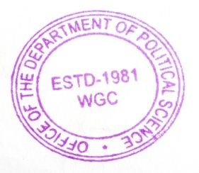

Add-on Course in Political Science

West Goalpara College.

Introduction : The department of Political –Science is started the Add-on Course to helpful to the our students and local citizens who are interested to political-science and Indian constitution. This course gives additional information and knowledge about the respective subject developed the skill.

Course II : The Indian President
Objectives of the course :
1) Knowledge about the Indian president
2) To understand the powers & functions of Indian president
3) To aware the constitutional position and real position of the Indian president
4) To understanding the parliamentary Government
Opportunity :

This course give the basic knowledge to the Indian president and his powers and functions, to understand real positions of president
Details of course :

This Addon course will be given to the students, West Goalpara College.

Course Contents :

01 The president of india
a) Introduction
b) Qualification & Election
c) Sclary & allowances
d) Impeachmeent Articals 61
e) Etc
02 the president powers and functions
a) Executive Power
b) Administrative powers
c) Judicial Power
d) Discretionary power
03) Emergency powers of the Indian president
a) Economic
b) Financial
c) National emergency
04) the constional Positions of Indian President
Reference Book:

1) The constitutional India By R.C. C. Sarkar Pub the institute of constitutational & parliamentary studies New Delhi
2) The role of the president of India by Laxmikant . Balkriishan K. Sagar Publication
3) The Indian Government & politics by D.D. Basu Lexis Nevis New Delhi

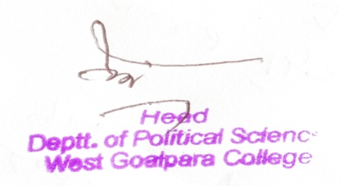
Head
Department of Political Science
West Goalpara College

DEPARTMENT OF POLITICAL SCIENCE
WEST GOALPARA COLLEGE: AMBARI
SESSION : 2021-22

REPORT OF 30 HOURS ADD-ON COURSE ON : THE PRESIDENT OF INDIA.

The department of Political Science, West Goalpara College conducted 30 Hours Add-on Course on “The President of India as per the due permission of the Principal and the proposal of the IQAC of the College to helpful to the our students
Who are interested to political science and Indian constitution and also the composition, power and function of the President of India. This course gives additional information and knowledge about the respective subject.

The Course duration was of three months starting from 24th January/2022 to 25th April/2022. Hafizur Rahman Asstt. Professor was the course coordinator of the programme and other faculties were engaged for conducting course smoothly . There are 61 nos of participants who are actively participated and successfully completed course .
The course completed on 25th April/2022 and in the closing ceremony , certificate were distributed among the participants by the Principal along with the Head of the Department of Political Science of the College in presence of other faculties.
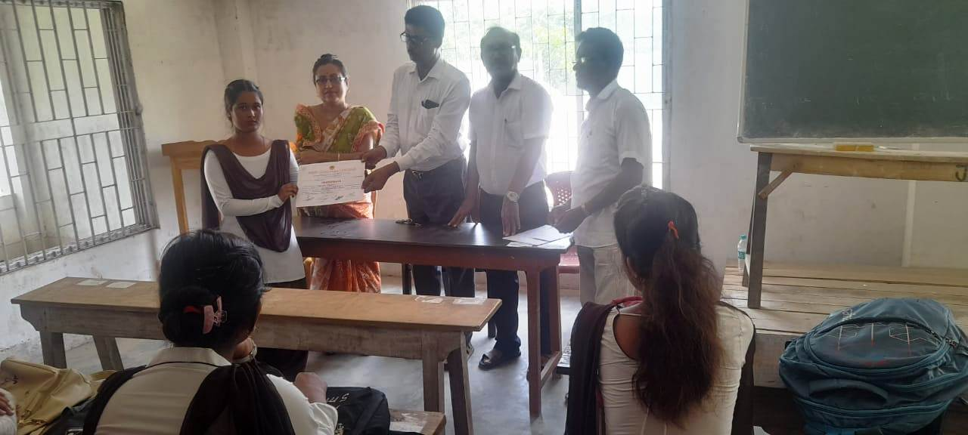

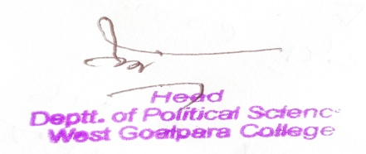
Head
Department of Political Science
West Goalpara College

