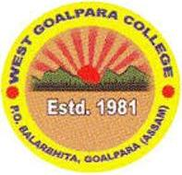
ACTIVITY REPORT
DEPTT. POLITICAL SCIENCE
WEST GOLPARA COLEGE
Sl.No. | Date | DESCRIPTION | PHOTO
01 | 25-01-2021 | Department of Political science of west Goalpara College has observed National Voters Day on 25th January..A lecture Programme was held on this occasion and Mr.Pradip Saikia Asso. Prof. Deptt. of economics present and delivered valuable speech as chief speaker of the programme. He talked about the importance and significance of the day.Mr.Jalal Uddin Ahmed HoD in political Science also delivered his lecture. In his speech he depicted the scenario of the ancient monarchical time and made comparison between Democracy and Monarchy. Mr shahjahan Ali sheikh offer vote of thanks of the Programme | 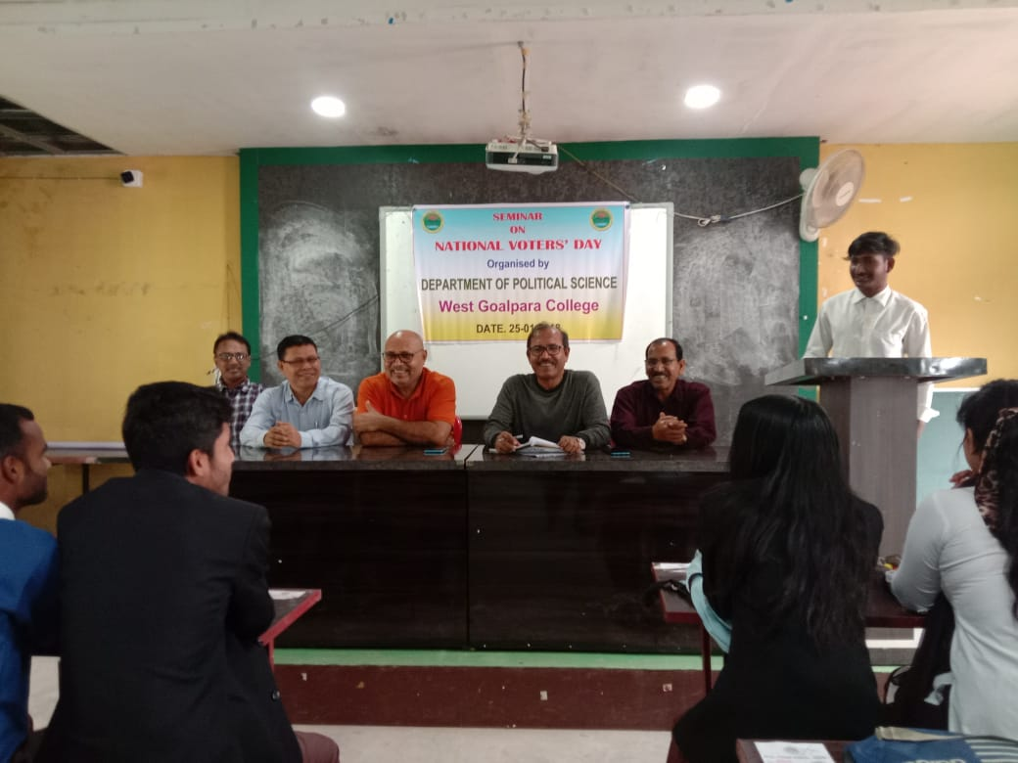

ACITIVITY REPORT
DEPTT. POLITICAL SCIENCE
Sl.No. | Date | DESCRIPTION | PHOTO
02 | 13.11.2021 | Department of Political Science of west Goalpara College was organised departmental “Freshmen Social” . In this occasion students performed various cultural activities Prof Shoriful Islam HoD in Arabic attend in the programme as chief Guest and he delivered valuable speech .senior students of the department also actively engaged in the programme and welcome the newcomers . all faculty members along with other department also present and delivered their valuable speeches | 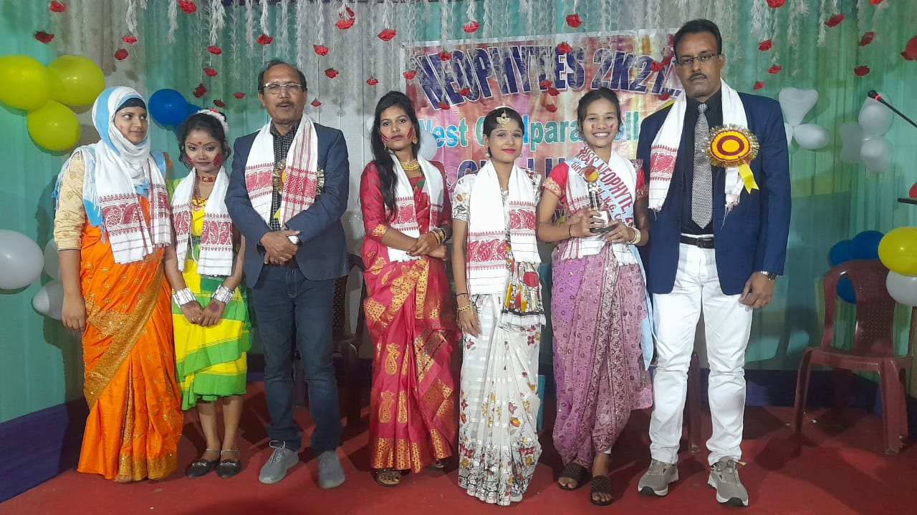

ACITIVITY REPORT
DEPTT. POLITICAL SCIENCE
Sl.No. | Date | DESCRIPTION | PHOTO
03 | 29th Sept/2022 | Department of Political Science of west Goalpara College was organised departmental “Freshmen Social” . In this occasion students performed various cultural activities Dr. Manisha Bhattacharya Principal, West Goalpara College attend in the programme as chief Guest and she delivered valuable speech .senior students of the department also actively engaged in the programme and welcome the newcomers . all the faculty members along with other department also present and delivered their valuable speeches. | 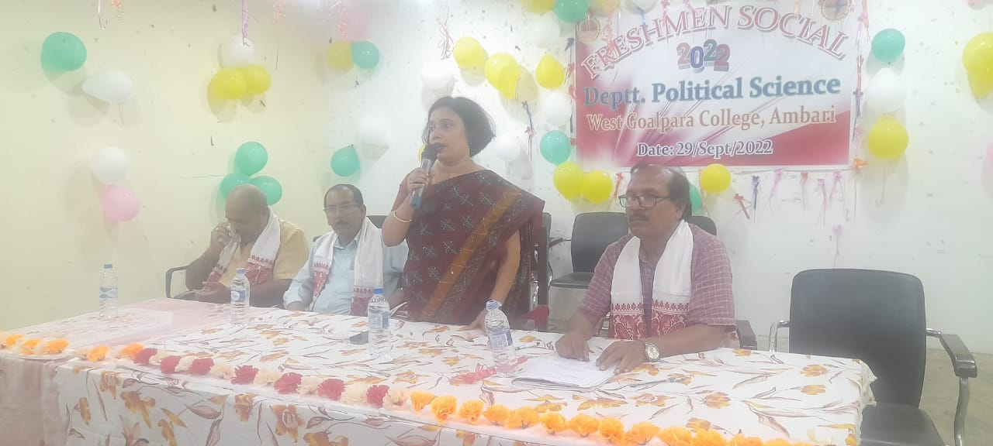

ACITIVITY REPORT
DEPTT. POLITICAL SCIENCE
Sl.No. | Date | DESCRIPTION | PHOTO
04 | 31st Oct/2021 | Department of Political Science of west Goalpara College was celebration of” RASTRYA EKTA DIVAS” ( Run for Unity) on the significance of birth anniversary of Sardar Ballab bhai Patel the First Home Minister of Independent India the Department also arranged a Rally for national unity. The Day is celebrated to mark the birth anniversary of Sardar Ballab Bhai Patel who had a major role in the political integration of India. In this connection a Rally was arranged by the department for national unity | 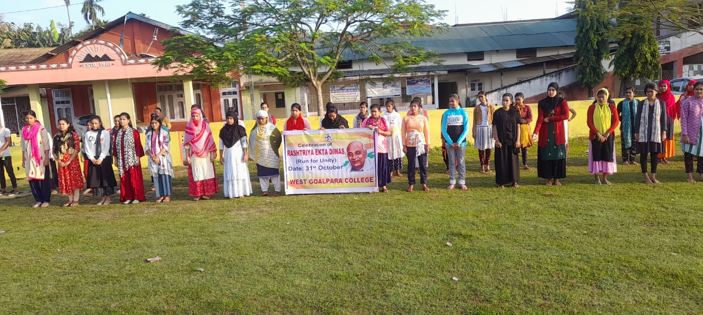

ACITIVITY REPORT
DEPTT. POLITICAL SCIENCE
Sl.No. | Date | DESCRIPTION | PHOTO
05 | 5th Sept/2022 | Every Year , TEACHER’S DAY is observed on September 5 to commemorate the birth day of Dr. Sarbapalli Radhakrishnan 2nd President of India. The Students of the department of political Science arranged Teachers .Prof. Osman Goni Mollah Red HoD Deptt. Political Science West Goalapra College attend in the programme as chief guest, delivered his valuable speech. In his speech he talked about Teacher’s Day is celebrated on September 5 every year in India to acknowledge the contribution of Teacher’s in the society .It was an auspicious day for students. The students of the department felicitated the Teacher’s . In concluding the programme the HoD Jalal Uddin Ahmed talked the role of Teacher’s in moulding the society and the ways to improve the present educational system. All the faculties and students were participated..  The programme ended with sweet distribution after the vote of thanks. | 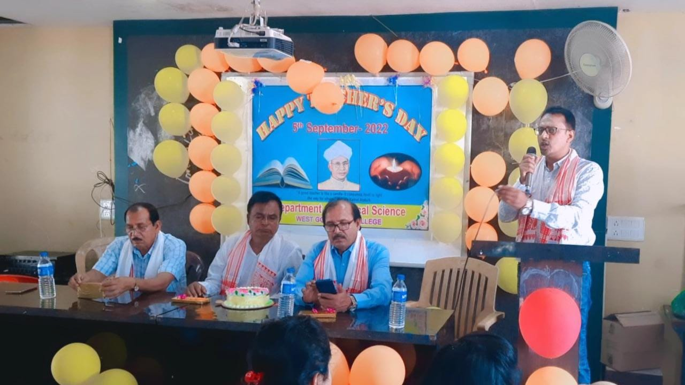
ACITIVITY REPORT
DEPTT. POLITICAL SCIENCE
Sl.No. | Date | DESCRIPTION | PHOTO
06 | 10-12-2021 | HUMAN RIGHTS DAY was organized by the department of Political Science, West Goalpara College.  The Theme of the 2021Human Rights Day is “ Dignity ,Freedom and Justice for all”  on the occasion Abdul Wahhab Miah Principal i/c West Goalpara College presided over the programme.  In the Introductions speech Prof. Jalal Uddin Ahmed, HoD in Pol.Sc. said that Universal Declaration of Human Right is a milestone documents which proclaims the in amiable rights that everyone is entailed no as Human being-regular of race, colour, religion, sex, language, Political or other opinion, national or social origin,  The Chief Guest Sri. B. Baruah ADC , Goalpara District keeping in view that Human Rights are Universal and everyone needs to be educated for them.  There are 95 nos students and Teachers participated in the Programme.aii the participants took oath by reading UN Charter. | 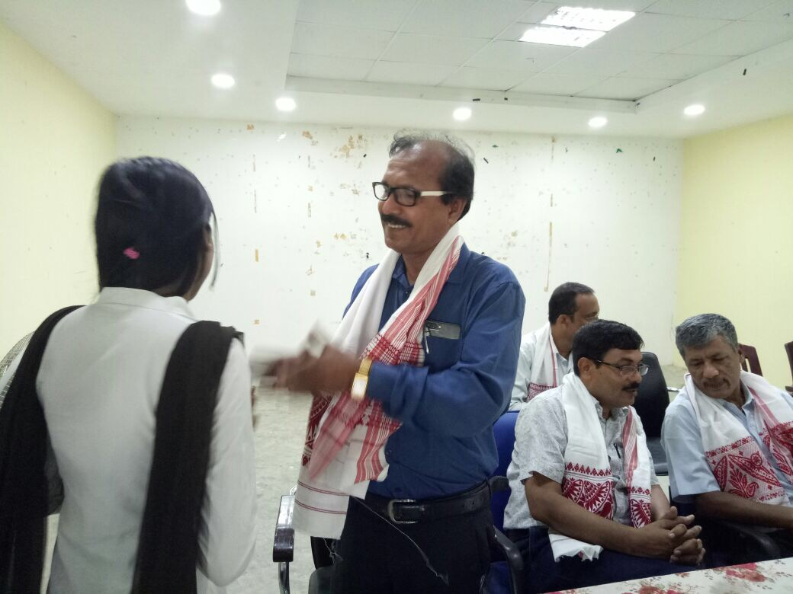

ACITIVITY REPORT
DEPTT. POLITICAL SCIENCE
West Goalpara College
 | Date | DESCRIPTION | PHOTO
07 | 19-02-2021 | A Department Seminar was organized by the department of Political Science in collaboration with IQAC among the Students of all Major classes. The Topic of the seminar was “ INTELLECTUAL PROPERTY RIGHT”, The seminar was presided over by Prof. Jalal Uddin Ahmed HoD in Political Science, West Goalpara College, The Seminar was inaugurated by Prof. Shoriful Islam, Coordinator IQAC West Goalpara College, in his inaugural speech he said that the intellectual property rights refers to the legal rights to the inventor or creator to protect his inventor or creation for a certain period of time.  The Resource person Prof. Pradip Saikia Associate Professor . West Goalpara College delivered his speech, he mentioned that the Intellectual Property Rights(IPR) are the given to persons over the creations of their minds inventions , literary and artistic works.  There are 155 nos Students and faculties were present in the seminars. At the end Prof. Hafizur Rahman Asstt. Prof. in Political Science offer vote of thanks | 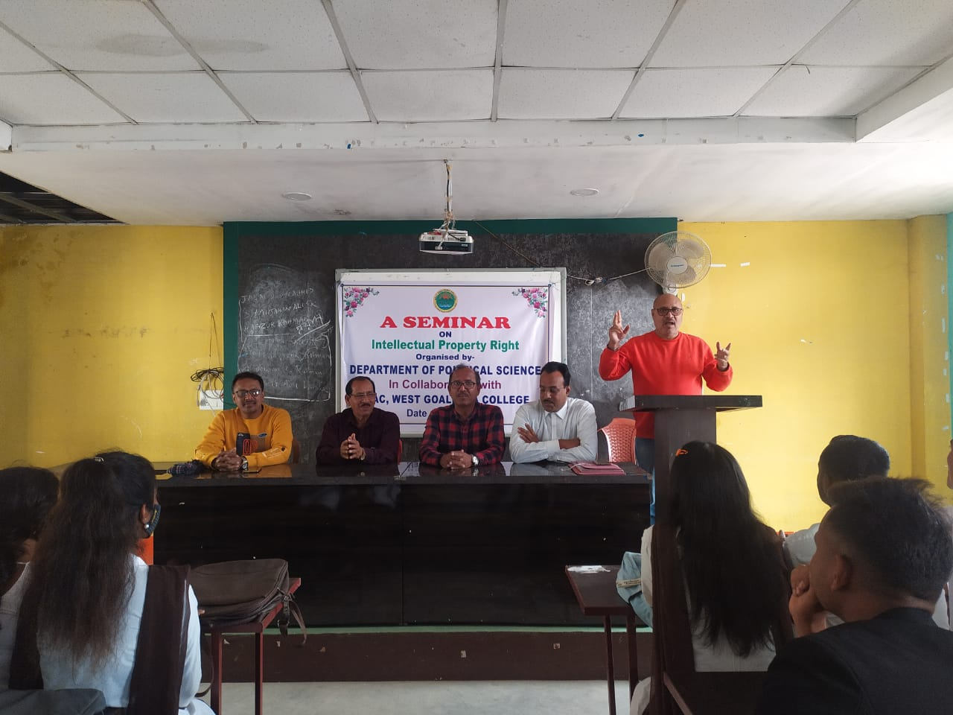

ACITIVITY REPORT
DEPTT. POLITICAL SCIENCE
 | Date | DESCRIPTION | PHOTO
08 | 02-05-2023 | On the occasion of IDUL FITRE Team Humanity Goalpara & Department of Political Science, West Goalpara College organized a “Free Health Check up and Awareness Camp” in Collaboration with S.L. Collegiate High School, Rakhaldubi Arunoday at S.L. Collegiate High School on 2nd May/2023  The Camp Inaugurated by Anita Hazarika Addl. Superintendent Police Goalpara . 150 Nos of Patents check up by Dr. Nozmul Hoque , Dr. Mosharaff Hussain ,Dr. Mamud Hasan and Dr Romjan Ali . They also distribution of free medicine. | 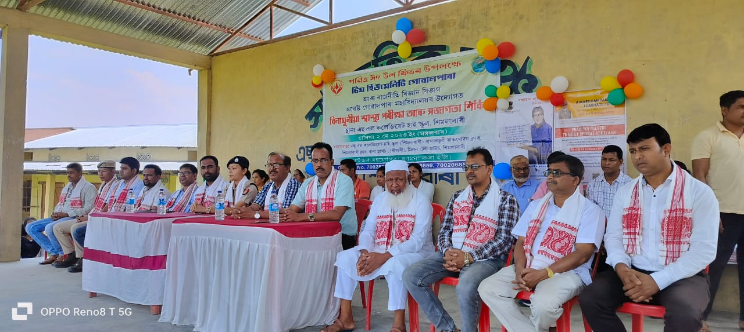

ACITIVITY REPORT
DEPTT. POLITICAL SCIENCE
 | Date | DESCRIPTION | PHOTO
09 | 02-05-2022 | Team Teaching is a group of two or more teachers working together to plan , conduct and evaluate the learning activities for the same group of learners it is also called collaborating teaching . The Department of Political Science was arrange Team for teaching students Today B.A. 2nd Semester(Homs) students to provide teaching by group of Teacher’s of the department namely Prof Jalal Uddin Ahmed, HoD, Prof. Shahjahan Ali Sheikh Asstt. Prof. Prof. Hafizur Rahman Asstt. Professor West Goalpara College . | 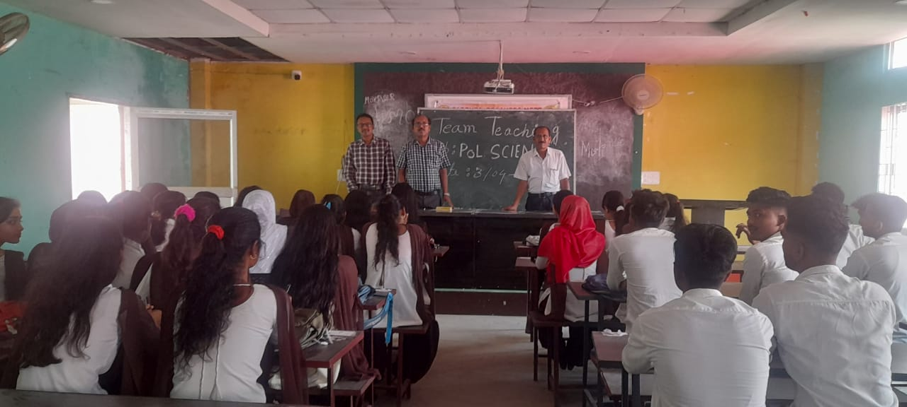

ACITIVITY REPORT
DEPTT. POLITICAL SCIENCE
 | Date | DESCRIPTION | PHOTO
10 | 04-05-2023 | FAREWELL /2023  B.A, 6TH SEMESTER  DATE 04.05.23  The “FAREWELL”Programme organized by the present students of the department of Political Science  The farewell programme presided over by the Prof. Jalal Uddin Ahmed HoD in Political science of West Goalpara College  The introductory speech offered by Ashraful Islam student of 4th Semester  . Laiy Suhana Sultana Nirufa Hassan, sanidul Islam ,Hasibul Hoque,Rasel Ahmed express their past experience in the college .The Chief Guest Prof. Osman Goni Mollah,& Guest Of Honour Prof. Khodeza Khatun president WGCTA delivered their valuable speech  In the Presidential speeches Prof. Jalal Uddin Ahmed said that farewell is not the last that you are going to see each other . Let us promise that we are going stay in touch with each other .  Riazul Islm offered vote of thanks. | 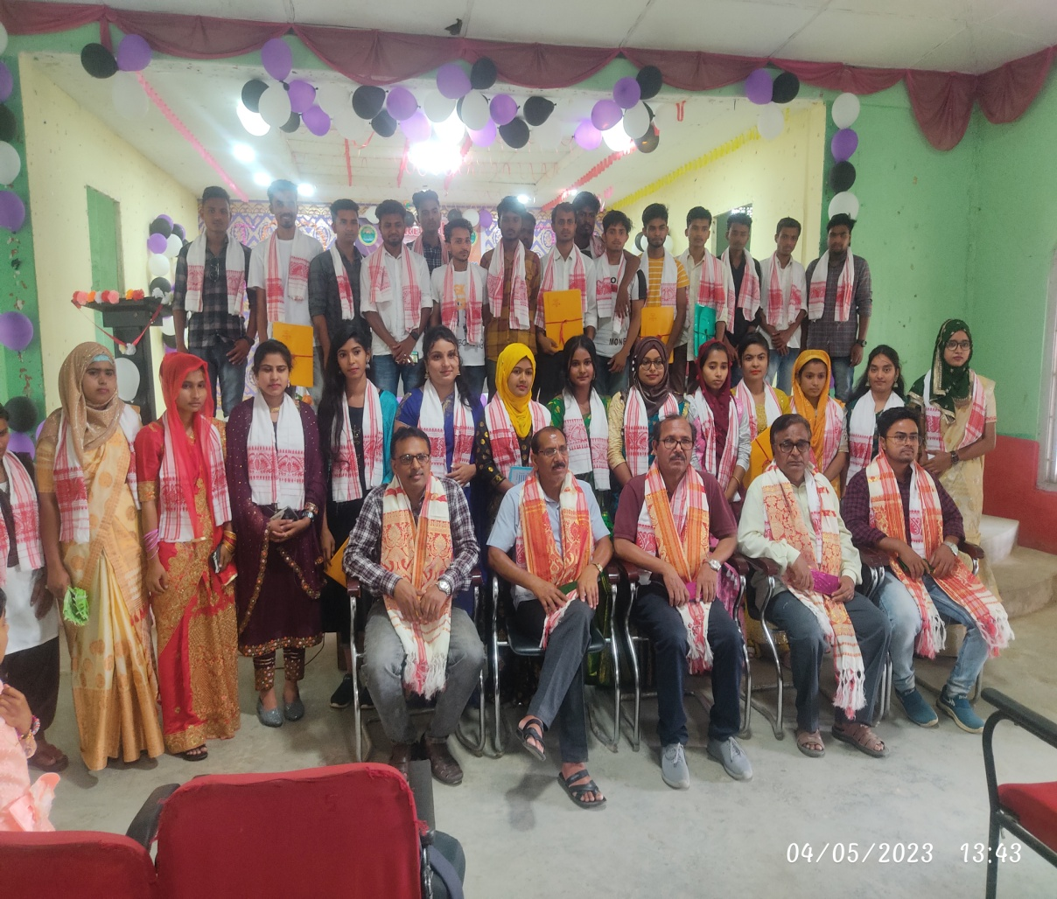

ACITIVITY REPORT
DEPTT. POLITICAL SCIENCE
 | Date | DESCRIPTION | PHOTO
11 | 03-05-2023 | The Department of Political Science organised PARENT –TEACHER MEET” on 3rd May/2023 at Digital Class Room at 10.30. am. There are 29 nos Parents are present. The programme Presided over by the HoD in Pol science Prof. Jalal Uddin Ahmed and Dr. Manisha Bhattacharyya Principal Of The College are present as Chief Guest. The Principal interact with the parents in various problems . The parents also point out some problems . The Principal assurance them to solve these problems Prof. Hafizur Rahman offered vote of thanks at the end of the programme, | 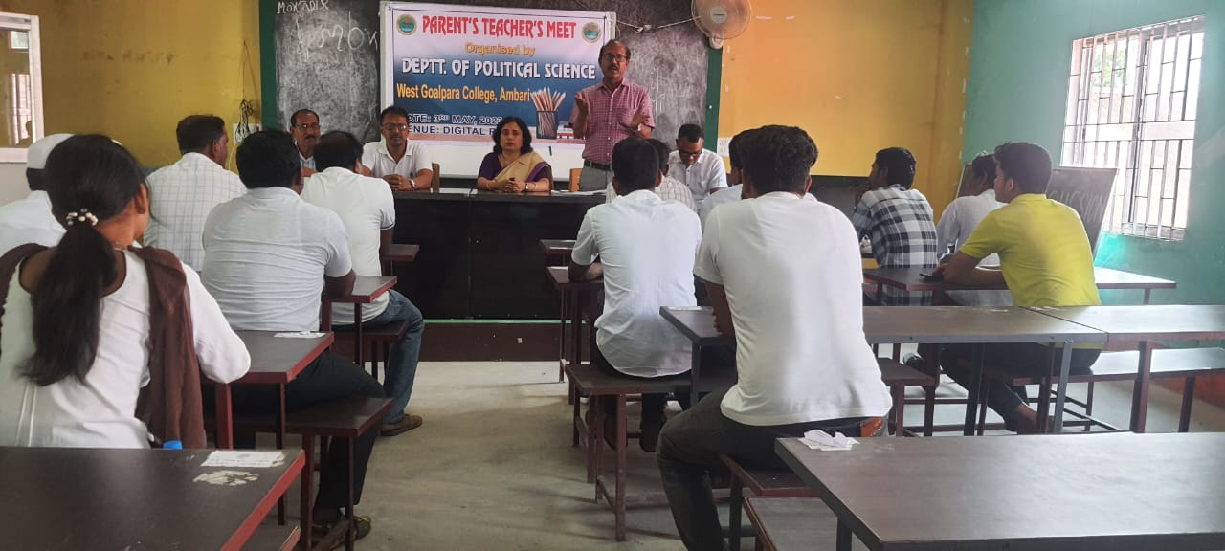

ACITIVITY REPORT
DEPTT. POLITICAL SCIENCE
 | Date | DESCRIPTION | PHOTO
12 | 02-05-2022 | Group Discussion regularly held in our department. Group Discussion is a method of learning where students discuss issues and ideas together .In GD students working groups to solve problems and learn from each other. It helps students develop their critical thinking skills, problems-solving abilities and communication skills. From above point the department of political science arranged group discussion among the students | 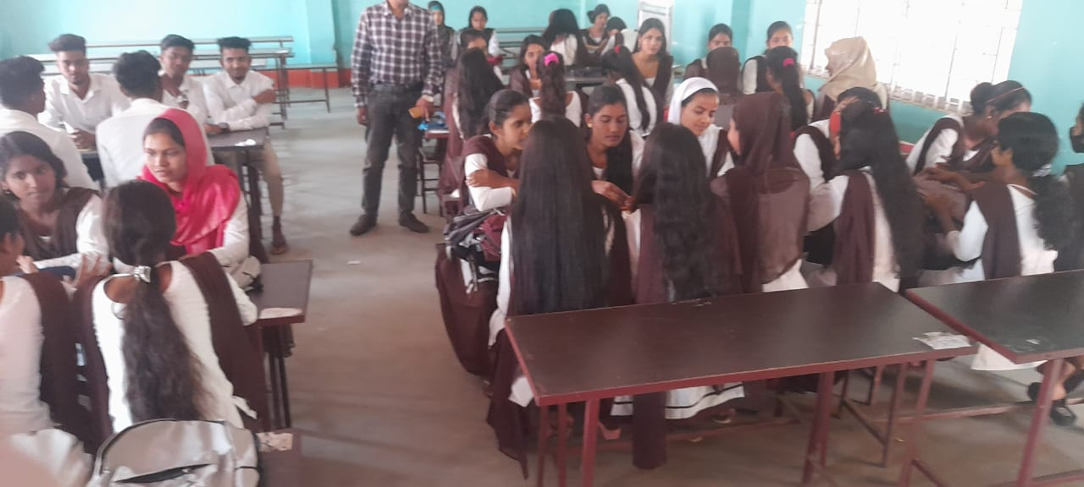

ACITIVITY REPORT
DEPTT. POLITICAL SCIENCE
 | Date | DESCRIPTION | PHOTO
13 | 11-05-2023 | Voluntary Blood Donation Camp  on the occasion of  “ WORLD THALASSEMIAMA DAY” organized by Blood centre, 200 Bedded Civil Hospital Goalpara  in collaboration with  Rakhaldubi Arunoday Club &  Department of Political Science  West Goalpara College .  Dr, Abdullah sheikh In- Charge ,.Blood Centre , 200 Bedded Civil Hospital Goalpara inaugurate the Blood Donation Camp. There are 20 nos donors, Donated blood to the Blood Bank, Civil Hospital Goalpara. | 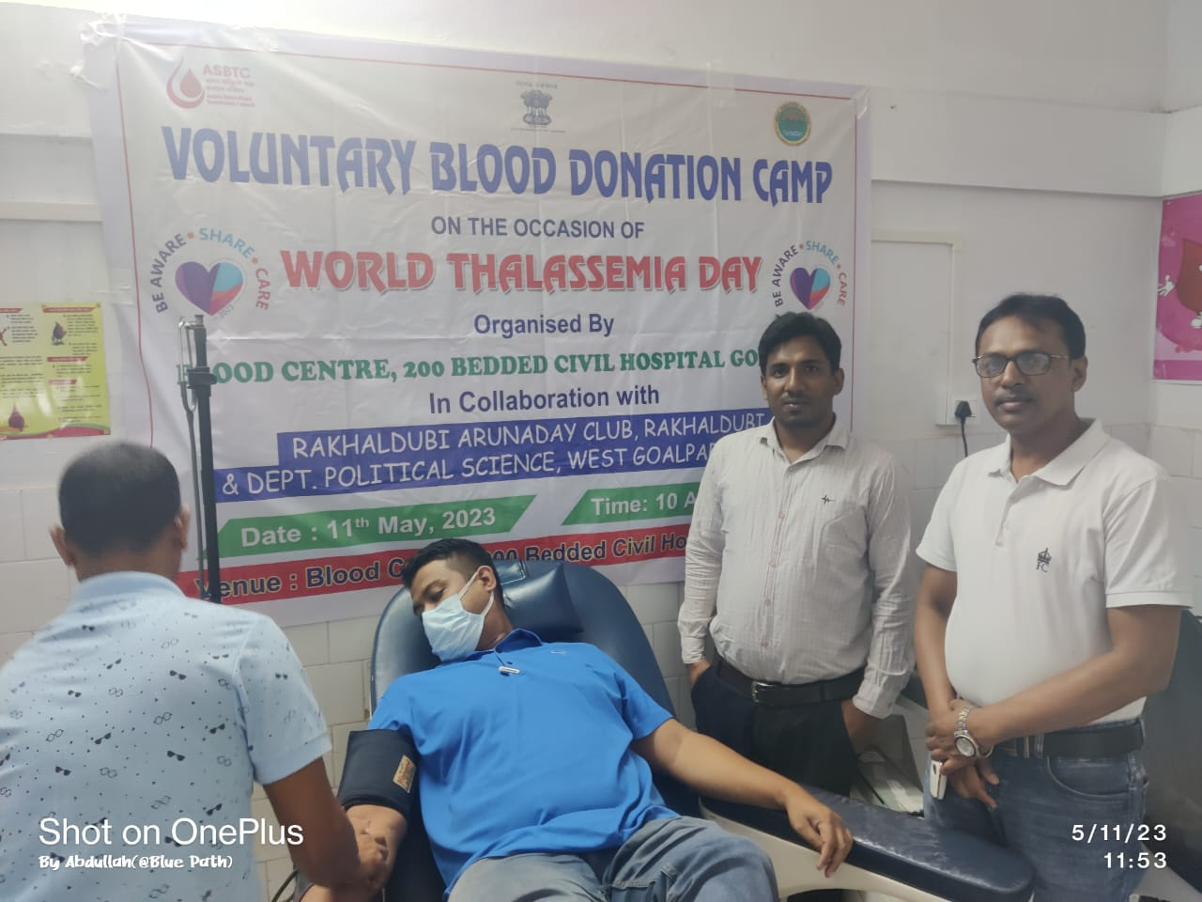

ACITIVITY REPORT
DEPTT. POLITICAL SCIENCE
 | Date | DESCRIPTION | PHOTO
14 | 03-05-2023 | The Department of Political Science organised PARENT –TEACHER MEET” on 3rd May/2023 at Digital Class Room at 10.30. am. There are 29 nos Parents are present. The programme Presided over by the HoD in Pol science Prof. Jalal Uddin Ahmed and Dr. Manisha Bhattacharyya Principal Of The College are present as Chief Guest. The Principal interact with the parents in various problems . The parents also point out some problems . The Principal assurance them to solve these problems Prof. Hafizur Rahman offered vote of thanks at the end of the programme,

ACITIVITY REPORT
DEPTT. POLITICAL SCIENCE
 | Date | DESCRIPTION | PHOTO
15 | 20-05-2023 | PEER TEACHING  The Department of Political Science of West Goalpara College arranged an activity namely PEER TEACHING , where 2nd Semester Students Rashidul Islam took a class on the topic” Fundamental Rights” in Indian Constitution. The primary objective of this programme to introduce the students to take part in the interactive session with the peer student | 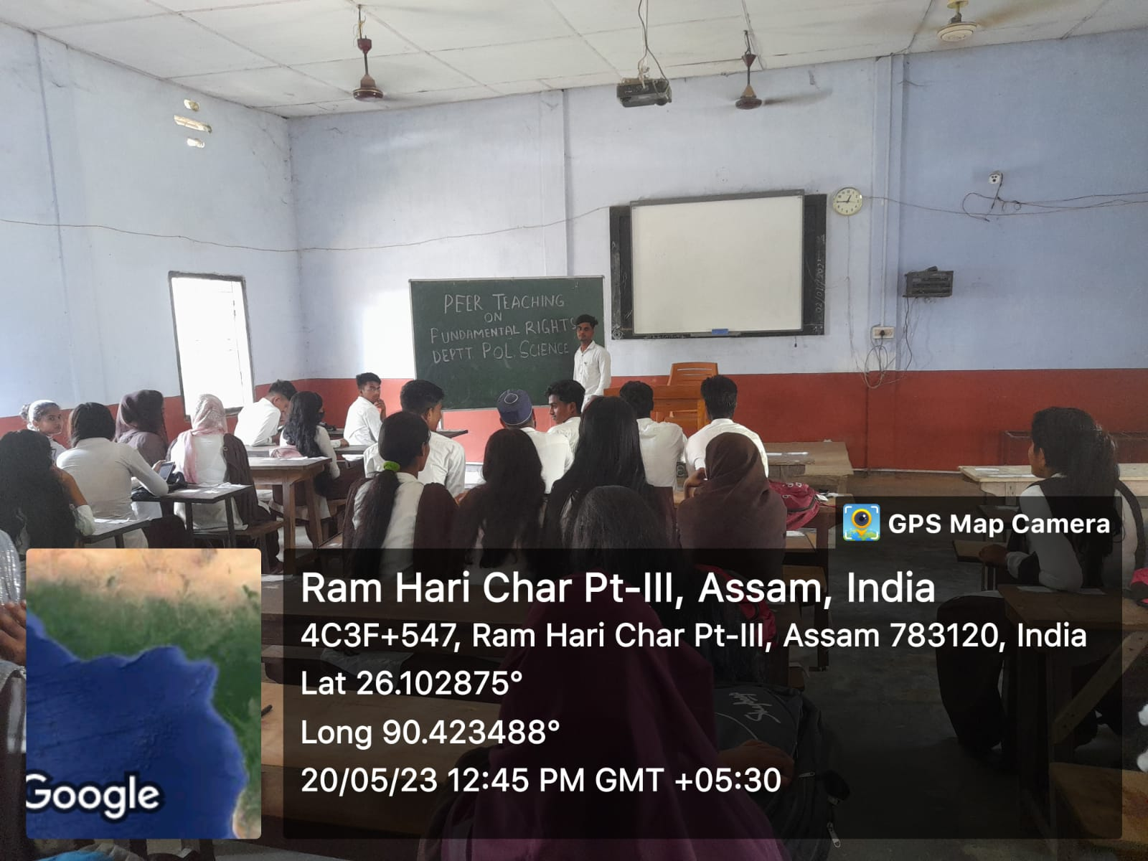

ACITIVITY REPORT
DEPTT. POLITICAL SCIENCE

 | Date | DESCRIPTION | PHOTO
16 | 20-05-2023 | On 20th May/2023 a Guest lecture ( as a part of faculty exchange programme) was organized by the Department of Political science. The was delivered by Prof. Khodeza Khatun Asso. Prof. Department of History,West Goalpara College. The Topic of the session was”CAUSES OF THE FIRST WORLD WAR”. The event was introduced by HoD in Political science Jalal Uddin Ahmed. | 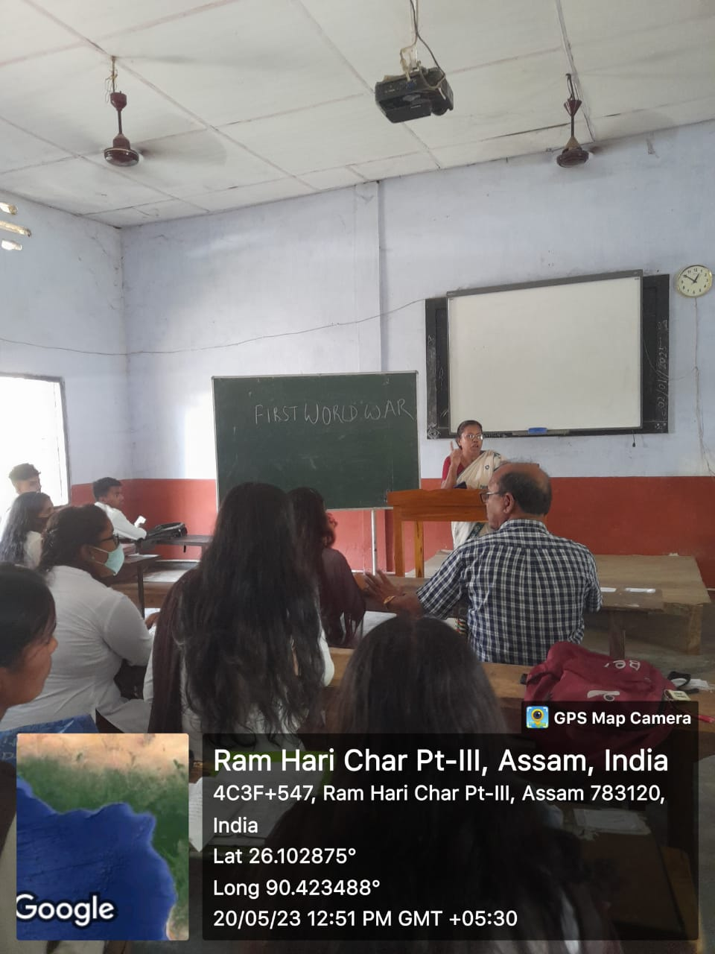

ACITIVITY REPORT
DEPTT. POLITICAL SCIENCE
 | Date | DESCRIPTION | PHOTO
15 | 27-05-2023 | PEER TEACHING  The Department of Political Science of West Goalpara College arranged an activity namely PEER TEACHING , where 2nd Semester( Hons)Students Ruhul Amin took a class on the topic” Secularism” in Indian Constitution. The primary objective of this programme to introduce the students to take part in the interactive session with the peer student .The faculty members S. Ali Sheikh and J.U. Ahmed also present in the class | 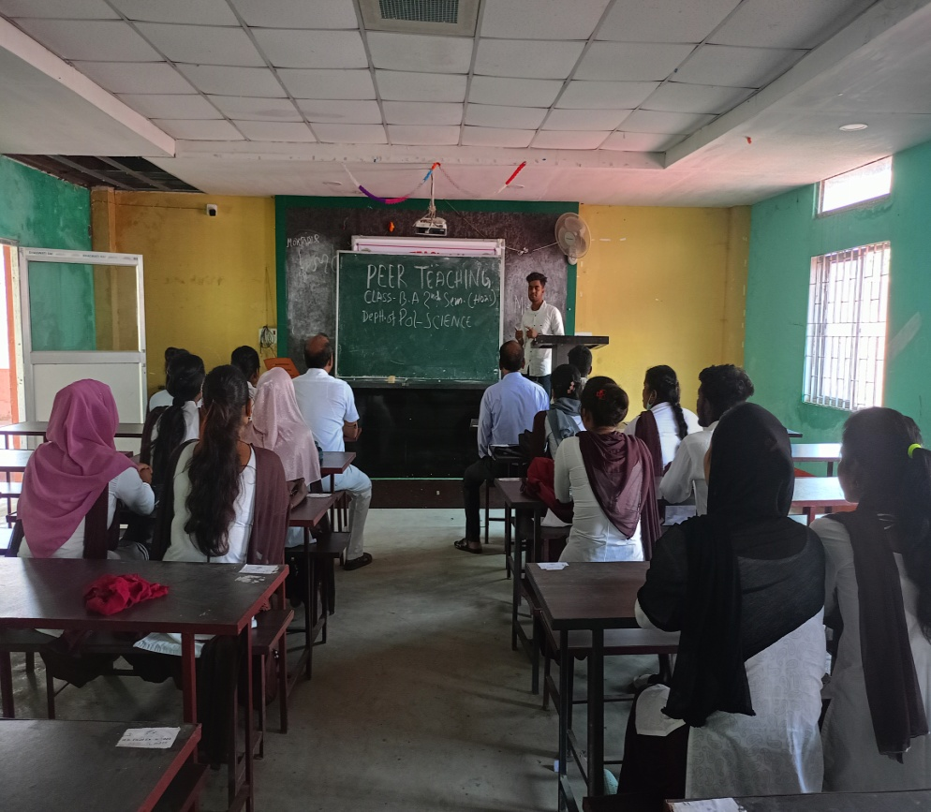

ACITIVITY REPORT
DEPTT. POLITICAL SCIENCE

 | Date | DESCRIPTION | PHOTO
12 | 27-05-2023 | Group Discussion regularly held in our department. Group Discussion is a method of learning where students discuss issues and ideas together .In GD students working groups to solve problems and learn from each other. It helps students develop their critical thinking skills, problems-solving abilities and communication skills. From above point the department of political science arranged group discussion among the students | 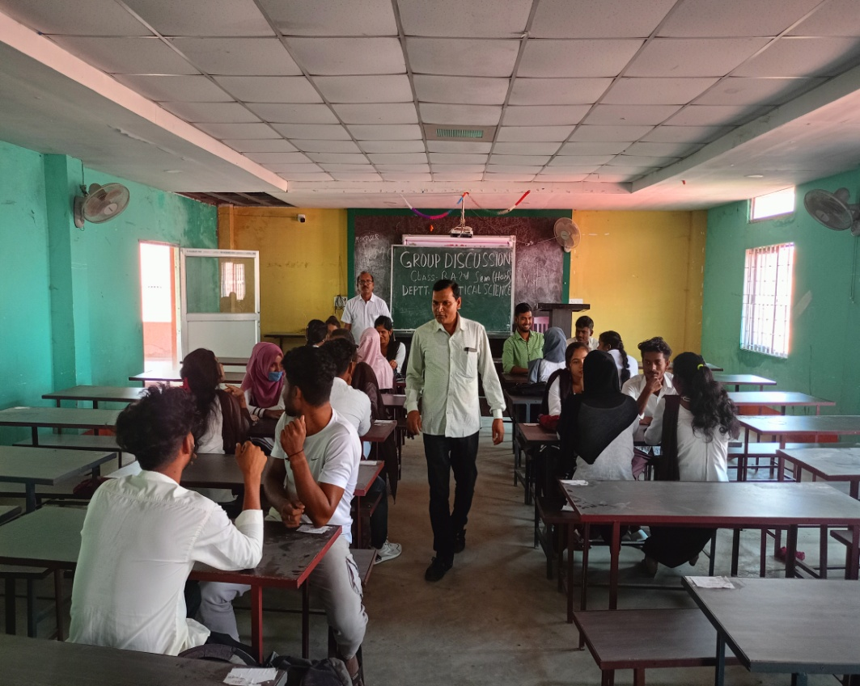

ACITIVITY REPORT
DEPTT. POLITICAL SCIENCE

 | Date | DESCRIPTION | PHOTO
16 | 20-05-2023 | On 27th May/2023 a “ Quiz competition” arranged by the department of Political Science where 7 nos of group participated in the competition after 3 round, group “C” Nilufa Yesmin and Bobita Yesmin got first prize. The Competition conducted by the HoD J.U.Ahmed and scorer was S. Ali Sheikh Asstt. Professor of the department of Political Science, West Goalpara College. | 