BEST PRACTICES
DEPARTMENT OF POLIYICAL SCIENCE
WEST GOALPARA COLLEGE

THE STUDENTS OF THE DEPARTMENT OF POLITICAL SCIENCE PARTICIPATED IN THE YOUTH PARLIAMENT ORGANISED BY THE DISTRICT ADMINISTRATION , GOALPARA AT GOALPARA COLLEGE AND GOT 2ND POSITION IN THE COMPETTITION ON 12TH SEPTEMBER 2018.

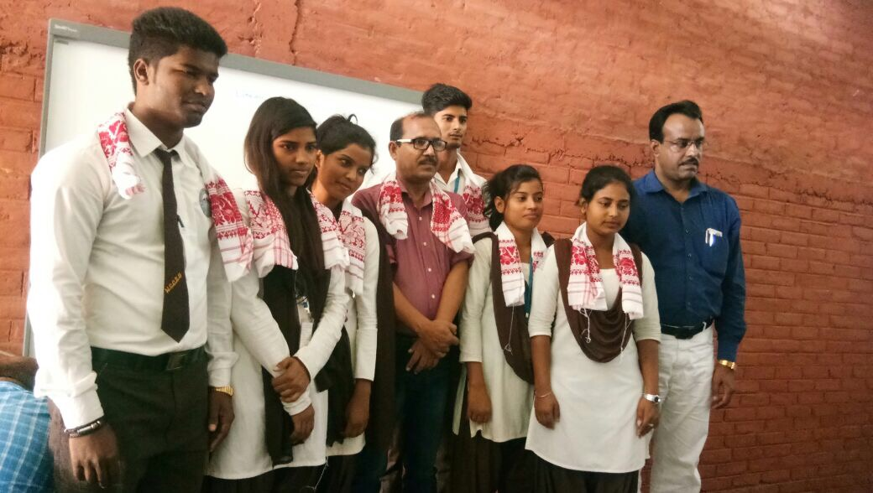
PARTICIPANTS ARE FALICIATED BY THE DEPARTMENT OF POLITICAL SCIENCE AFTER GOT 2ND POSITION IN THE COMPETTITION OF YOUTH PARLIAMENT ORGANISED BY DISTRIC ADMINISTRATION, GOALPARA.

